 BSP COASTWATCH QUESTIONNAIRE

Survey is to be done: 12. – 25. 09.
This questionnaire is for 500 m of shoreline

A INFORMATION ON SITE AND SURVEYORS
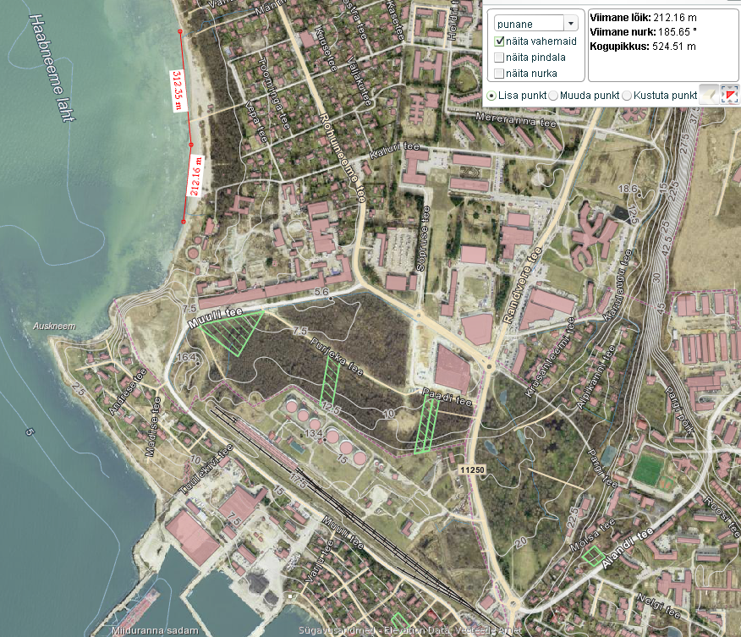

A1

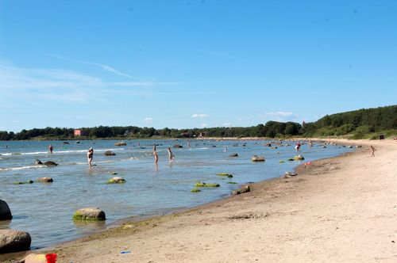

A 2 Map name of the survey area or unit Haabneeme beach.

A3 School name and address: Viimsi Secondary Scool
Randvere tee 8,
Haabneeme

A31 Teachers name, class and number of
students taking part of survey:
Karin Keert, 8th class, 6 students

A 32 Address of school and teacher´ e-mail
kool@viimsi.edu.ee, karin.keert@viimsi.edu.ee

A 4 Date of the survey /day/month/year/ 27.05.16

A 5 Do you know your site: Well * ₁ A little ___ ₂ Here on 1st or 2nd visit ___ ₃

A 6 Is your unit (part of) specially designated area? Yes * ₁ No ___ ₂ Don´t know ___ ₃

A 7 If your unit is specially designated please mark:

UNESCO Biosphere Reserve __ ₁
Ramsar Site ___₂
National Park ___ ₃
Nature or Marine Reserve ___₄
Other designation of natural importance___₅
Bathing water _* ₆

A 7 Is access to your coastal unit:

Easy by foot/vehicle * ₁ Difficult or normally ___ ₂ Tick, if access is prohibited___ ₃
impossible by foot/vehicle

B INFLUENCES FROM LAND immediate hinterland up to 500 m beyond the splash zone

B 1 Is the immediate hinterland (up to 500 m from splash zone) mainly devoted to:
(tick up to five boxes if necessary )

Intensive grazing ___ ₁
Tillage farming incl. horticulture___ ₂
Scrub or rough grazing * ₃
Dunes ___ ₄
Park/woodland/forest ___ ₅
Wetland (bog, marsh, lagoon) ___ ₆
Rock/sand * ₇

Village or residential *₈
Tourist resort ___ ₉
Waste tip ___ ₁₀
Industry, port industry, power station ___₁₁
Transport: road, train port, marinas ___₁₂
Construction site ___ ₁₃
Military zone ___ ₁₄
Other ___ ₁₅

B 2 Please count inflows as you walk your unit. Give details up to 4 inflows in the order

encountered. If there are more than four, choose the most important in terms of potential
pollution impact.

 | 1 |  | 2 |  | 3 |  | 4
Type of inflow Write P = pipe, S = Seepage, OD = open drain, Storm drain or irrigation canal, R = River/stream, lagoon inflow | OD |  | OD
Size of inflow: Small = 1, Medium = 2, Large = 3 | 1 |  | 1
Please tick for each inflow if it has…  Signs of animal life in the water? |  | 3 |  | 3 |  | 3 |  | 3
Has the inflow a bad smell? |  | 4 |  | 4 |  | 4 |  | 4
Discoloration/scum/froth from pollution? |  | 5 |  | 5 |  | 5 |  | 5
Dead fish? |  | 6 |  | 6 |  | 6 |  | 6
Dumped debris in or beside inflow? |  | 7 | X | 7 |  | 7 |  | 7
Visible sewage? |  | 8 |  | 8 |  | 8 |  | 8
Oil or petrol or diesel? |  | 9 |  | 9 |  | 9 |  | 9

Total number of inflows in unit 2

C SPLAZH ZONE the shoreline from mean high water up to spring high water

C 1 Indicate what the area is mainly composed of: (tick maximum 2 categories)

Solid rock  1 | Boulders  20 cm +  2 | Gravel  0.2-20 cm  3 | Sand  X 4 | Silt or Mud  5 X | Other  (built walls)  6

C 2 Which of the plants listed did you find in your unit?

Reed bed  1 | Sea Grass  Zostera  2 | Brown  or Red Algae  X  3 | Green algae |  | Dislodged decaying algae  X 6 | Other  7
Reed bed  1 | Sea Grass  Zostera  2 | Brown  or Red Algae  X  3 | Patches or thin band  X 4 | Extensive cover or thick mats  5 | Dislodged decaying algae  X 6 | Other  7

C 3 Size of bladder wrack Fucus vesiculosus, varies in different areas of the Baltic Sea
depending on living conditions. If you have found bladder wrack in your area, please
take 3 – 5 plants and measure the length of the plant from the attaching place to the
top of the longest branch and calculate the average.
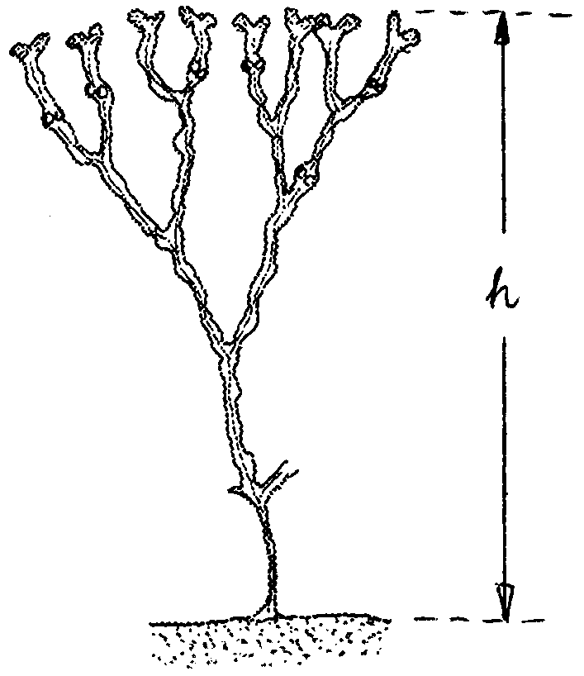

Plant was attached yes___ no *

Average length of bladder wrack 16 cm

Look carefully bladder wrack plants. Are
there growing other alga (hair, filaments ).
none _X a few _ many ____

C 4 If you know area well indicate whether there was any visible

algal blooms in water this spring or summer

Yes X₁ No ___ ₂ Don´t know ___ ₃

C 5 Indicate which of the animals listed you found live (L) or dead (D):

Jellyfish | Worms and wormcasts | Shellfish eg cockles, winkles |  | Crustaceans eg crabs |  | Fish |  | Seabirds |  | Seals |  | Dolphins |  | Rats
1 | 2 | L  3 | D  X  4 | L  5 | D  6 | L  7 | D  X  8 | L  X  9 | D  10 | L  11 | D  12 | L  13 | D  14 | L  15 | D  16
How many of each? → |  |  |  |  |  |  |  | 10 | 0 | 0 | 0 | 0 | 0 | 0 | 0

C 6 Which of the following animals were you lucky to find along your part of the shore?

Blue mussel Mytilus edulis   none * a few  many  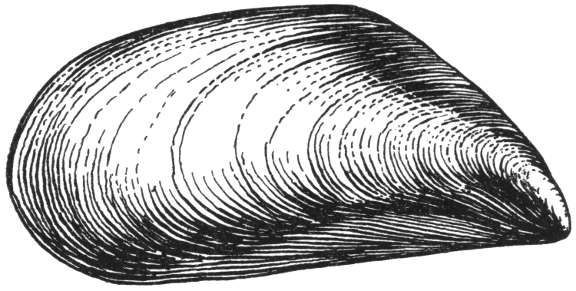  Length 1.5 – 10 cm | Baltic clam Macoma baltica   none * a few  many  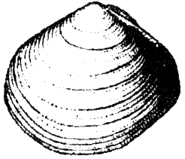  Triangular shell | Mya arenaria   none * a few  many    Oval, up to 12 cm long
Common cockle Cerastoderma glaucum   none * a few  many  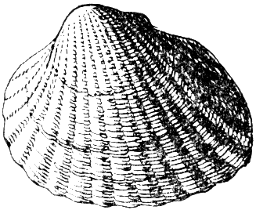  Heart- shaped, transverse ridges | Gammarus sp.  *none  a few  many  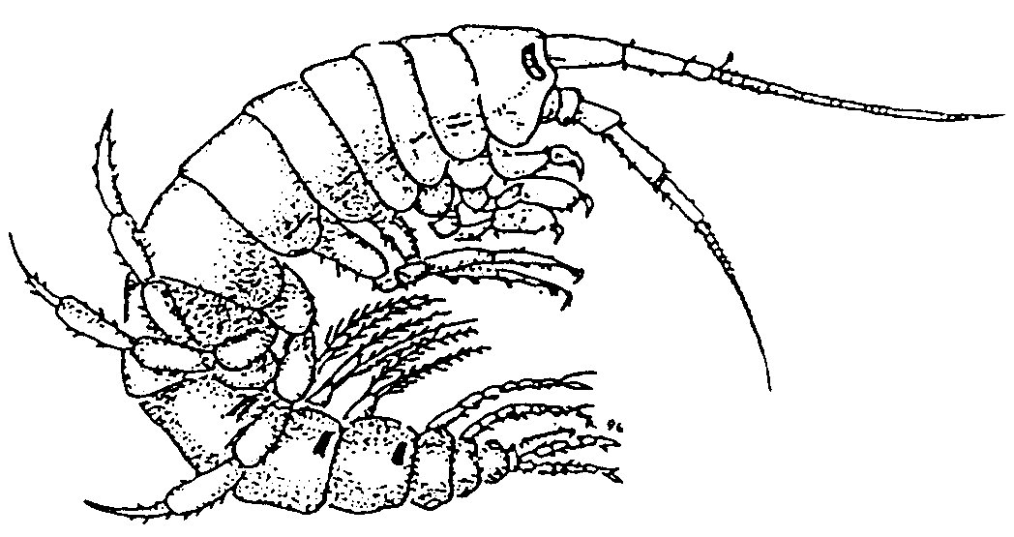

C 7 Did you find any visibly oiled birds (live or dead) during your survey? 0

How many live oiled birds? 0 How many dead oiled birds? 0

D GENEARAL LITTERING

D 1 Tick any major item(s) found on your unit

Landfill materials (e.g. concrete, rubble, debris from sea defences etc.) | 1 | -
Large metal objects e.g. abandoned vehicles, girders (exclude bins) | 2 | -
Household furnishings (beds, carpets, pieces of furniture etc.) | 3 | -
Household refuse in bags or piles of rubbish | 4 | X
Ship wreckage or small metal parts of ship wreckage | 5 | -
Dumped crops (potatoes, onions etc.) | 6 | -

D 2 Please count each type of beverage container, can holders, tyres and plastic
shopping bags found anywhere on the shore. If the number is too large to count,
estimate it.
Use dashed lines
for tally IIII III
I_______________________ 1 Glass bottles (drinks)

________________________ 0 Metal drinks containers

________________________ 0 Plastic drinks containers

_________________________ 0 Can holders

_________________________ 0 Paper or lined paper
drinks containers

I _______________________ 1 Tyres (Half a tyre or more = 1)

I _________________________ 1 Plastic shopping bags

D 3 Tick which of the following items of general litter or pollution you found on your
unit:

Lost or discarded plastic fishing & aquaculture gear (nets, lines, bags) | 1
Packing straps | 2
Hard plastic containers (including crates) | 3
Foamed polystyrene and polyurethane | 4
Sanitary material (incl. condoms, sanitary towel) | 5
Other plastics (not sanitary, bottles, bags, can holders, straps) | 6 | x
Tar, oil, petrol, diesel | 7
Containers of potentially hazardous substance (chemicals etc.) | 8
Textiles, shoes, gloves, items of clothing | 9 | x
Paper, cardboard, worked wood, vegetable waste | 10 | x
Food, fish waste and bones | 11
Faeces (mammal incl. human) | 12
Medical waste e.g. syringes, plasters | 13
Glass (including light bulbs) | 14 | x
Cans (including non-hazardous spray cans, camping gas) | 15

E GENERAL OBSERVATIONS

E 1 Has recent weather made the appearance of your coastal unit change?

Yes, it looks cleaner than usual __₁ Yes, looks worse than usual ___ ₂
No, recent weather is insignificant X ₃ Don’t know _{____ 4}

E 2 Has the beach been cleaned within the last week?

Yes ___ ₁ No X₂ Don’t know _ ₃

E 3 Is there any planned change of character (positive or negative) which is imminent
for this coastal unit?

Yes ___ ₁ No X₂ Don’t know ___ ₃

E 4 If you have evidence of a serious risk or imminent planned change for the worse,
please tick up to five boxes which describe the principal risk or imminent negative
changes

no, we have not

Erosion  1 | Beach mining  2 | Construction  3 | Dumping/ tipping  4 | Water pollution | Recreational abuse  X  1 0 | Other  11

Sewage  5 | Radioactivity  6 | Oil  7 | Industry  8 | Agriculture or industrial farming  9

E 5 Please enter an short comment or observation:

