Baltic Sea Project Phenological Studies Programme

OBSERVATION TABLE – SPRING 2014

Teacher name | Tiina Gashkov
Participant name and age  (or number of pupils) | 20 pupils, 7.form (13-14 years old)
Name of school | Jõhvi Secondary School
Address of school/Code | Hariduse 5, Jõhvi 41 534
Country | Estonia
E-mail-address | Tiina.gashkov mail.ee
Internet-address of school | www.johvig.edu.ee
GPS coordinates | 59º35` 27º42`

Picture of the species | What to observe | 1. Date  2. Day of 2014 | Place of observation (habitat), remarks
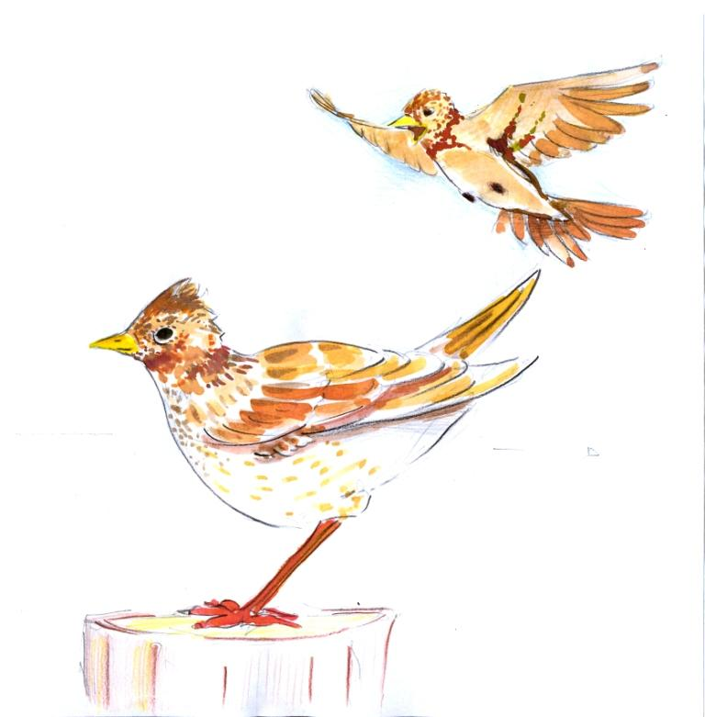 | When did You hear the voices of skylark  (Alauda arvensis)? | 1.7.03  2.66 | field
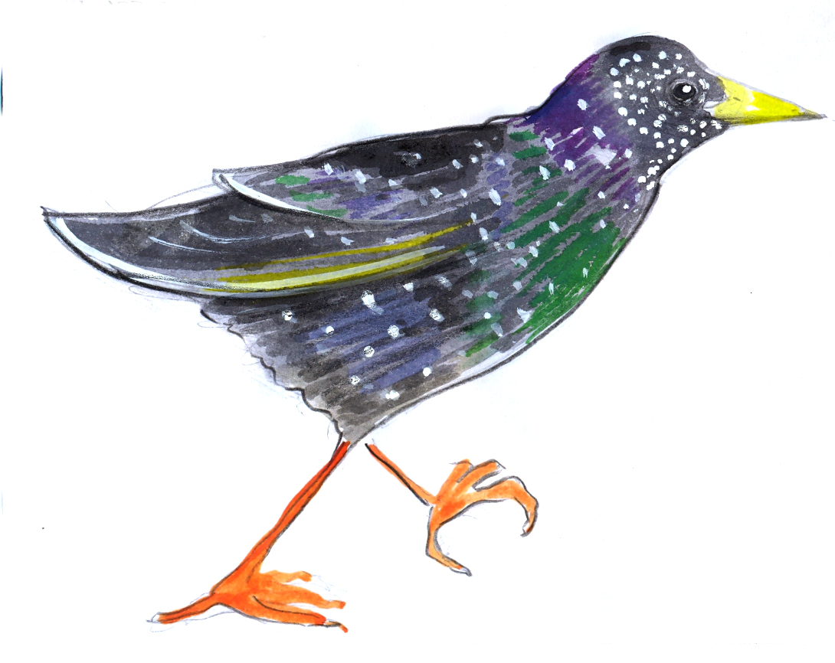 | When did You see the first starling (Sturnus vulgaris)? | 1.11.03  2.70 | town
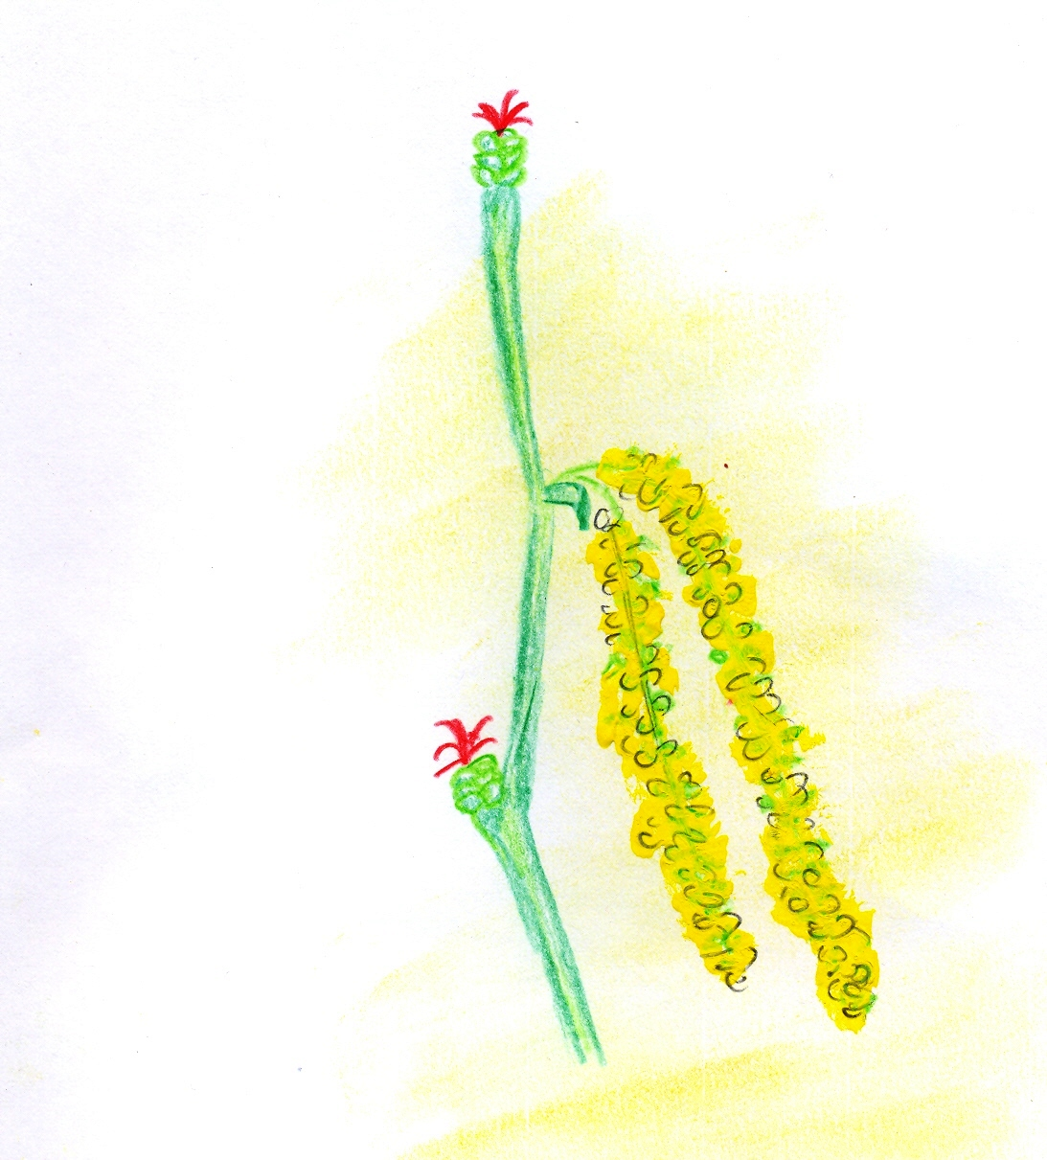 | When did You see the first hazelnut (Corylus avellana) being in bloom? | 1.12.03  2.71 | park
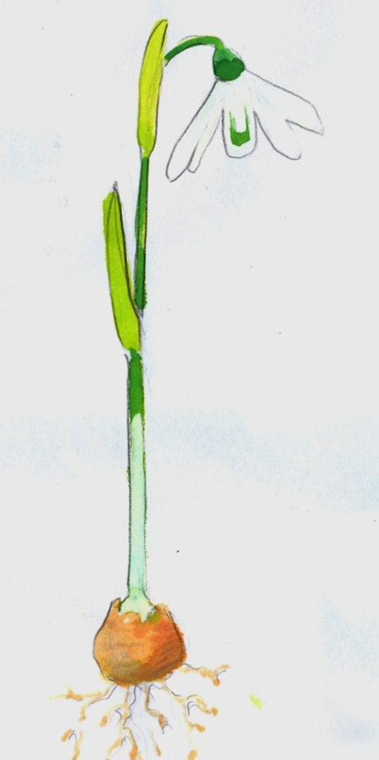  Baltic Sea Project Phenological Studies Programme | When did You see the first blooms of snowdrop (Galanthus nivalis)? | 1.1.03  2.60 | garden
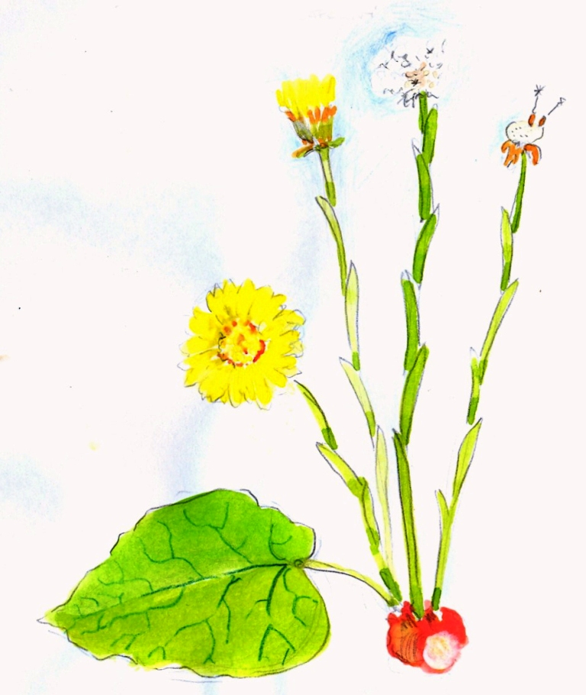 | When did You see the first blooms of coltsfoot (Tussilago farfara)? | 1.12.03  2.71 | field
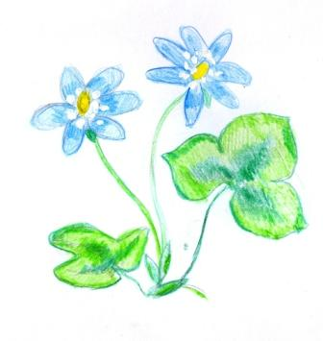 | When did You see the first blooms of blue anemone (Hepatica nobilis)? | 1.25.03  2.84 | park
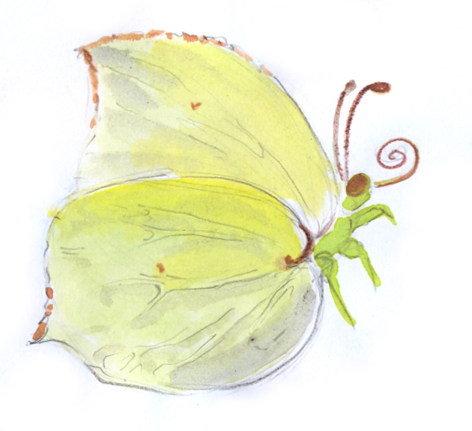 | When did You see the first brimstone (Gonepteryx rhamni)? | 1.29.03  2.88 | garden
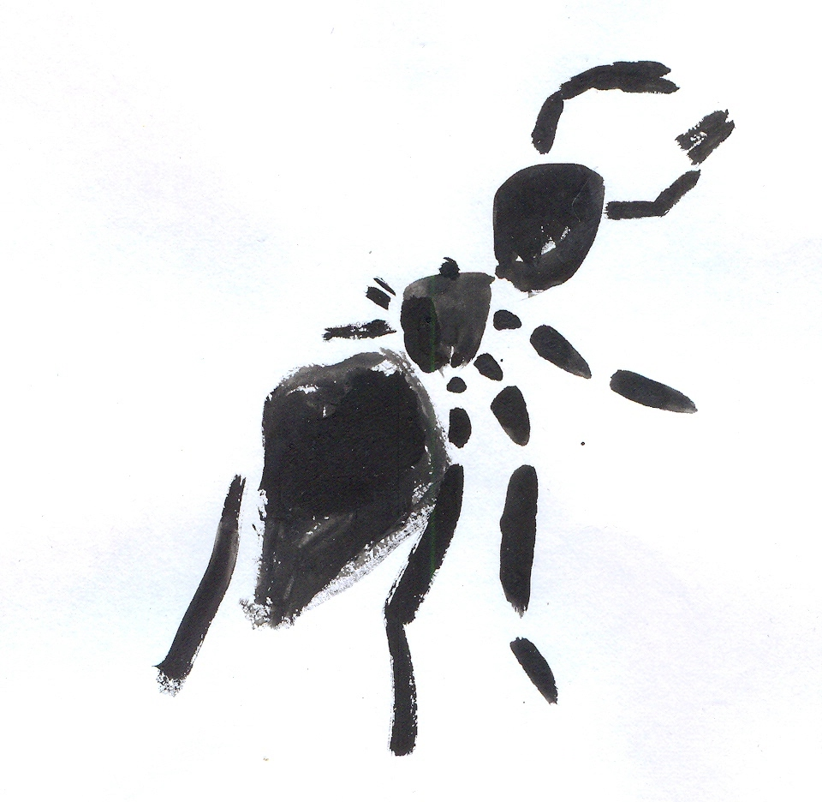 | When did You see the first black ant? | 1.  2.
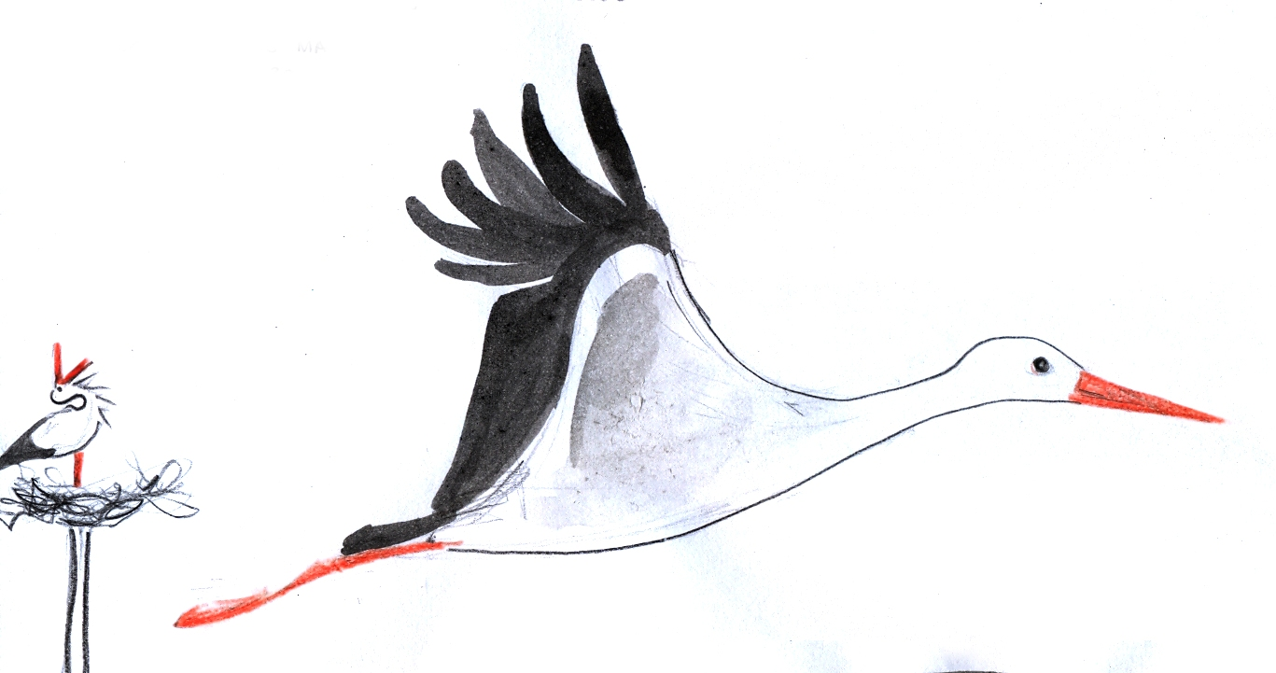 | When did white stork  (Ciconia ciconia) arrive? | 1.30.03  2.89 | village
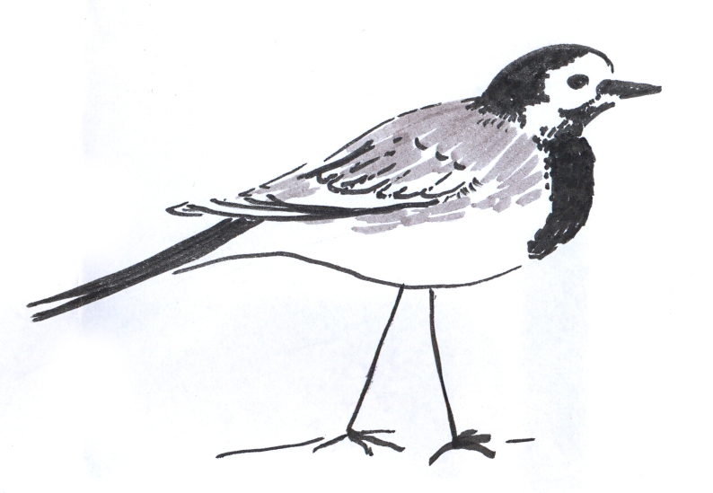 | When did You see the first wagtail (Motacilla alba)? | 1.10.04  2.100 | village
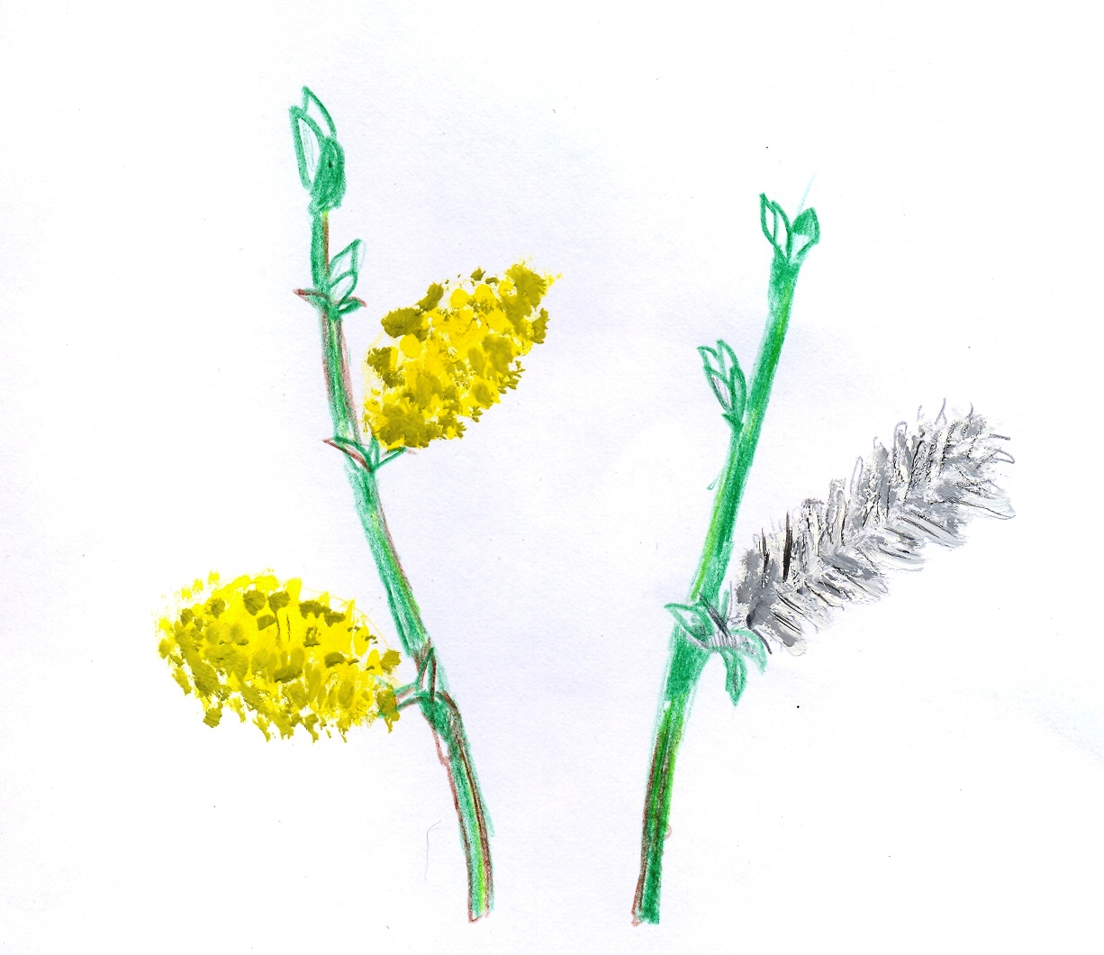 | When did You see the first sallow (Salix caprea)  being in bloom? | 1.10.04  2.100 | park
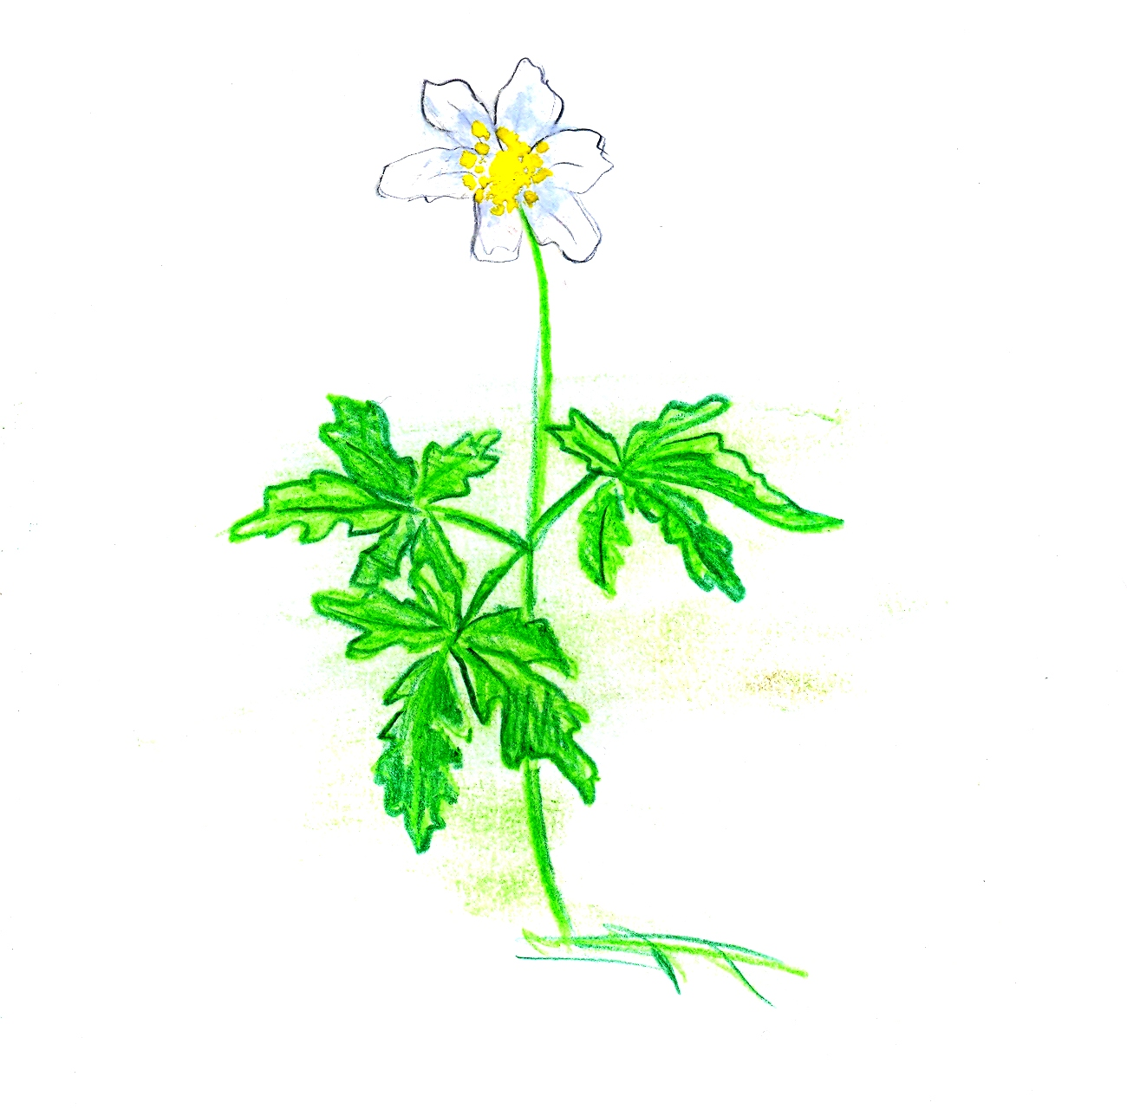 | When did You see the first blooms of wood anemone (Anemone nemerosa)? | 1.18.04  2.108 | forest
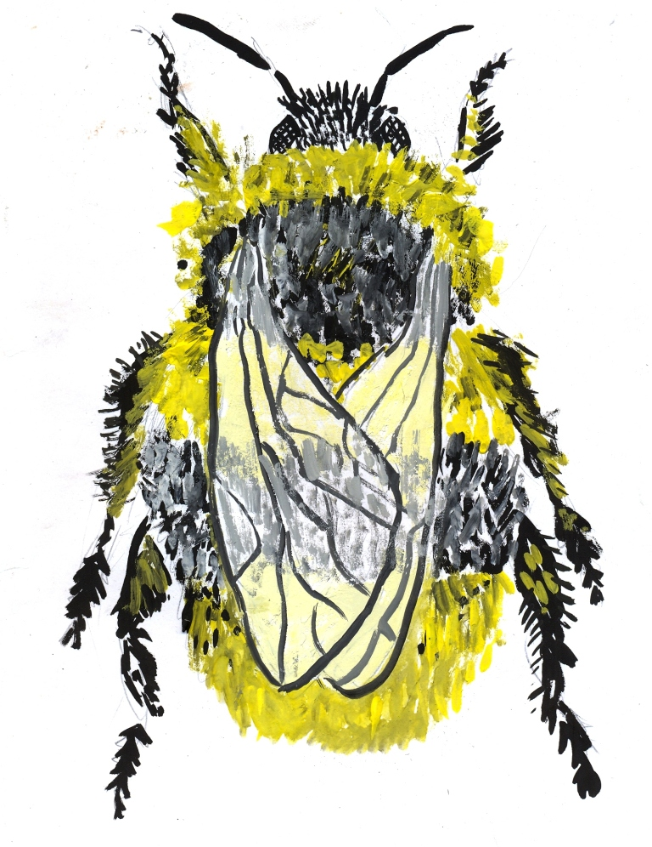 | When did You see the first bumble-bee flying? | 1.23.04  2.113 | field
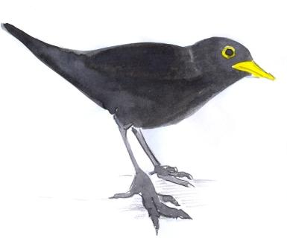  Baltic Sea Project Phenological Studies Programme | When did You hear the voices of blackbird  (Turdus merula)? | 1.8.04  2.98 | park
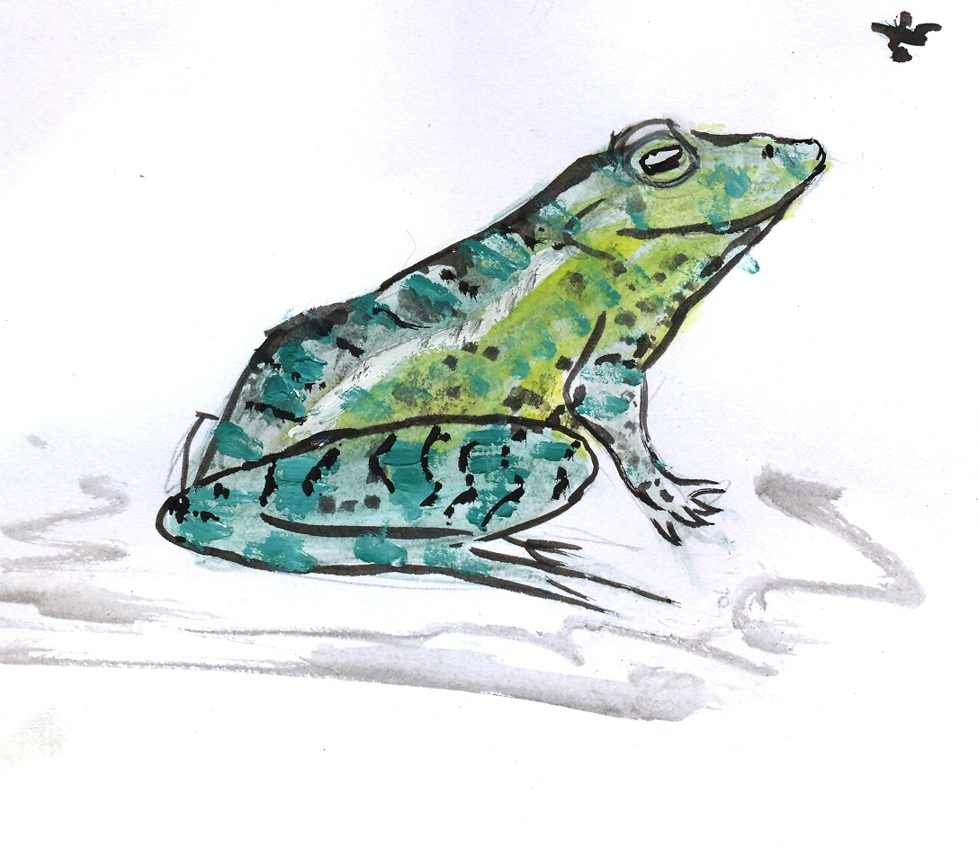 | When did you hear the “frog concert” in the vociferously breeding pond? | 1.18.04  2.108
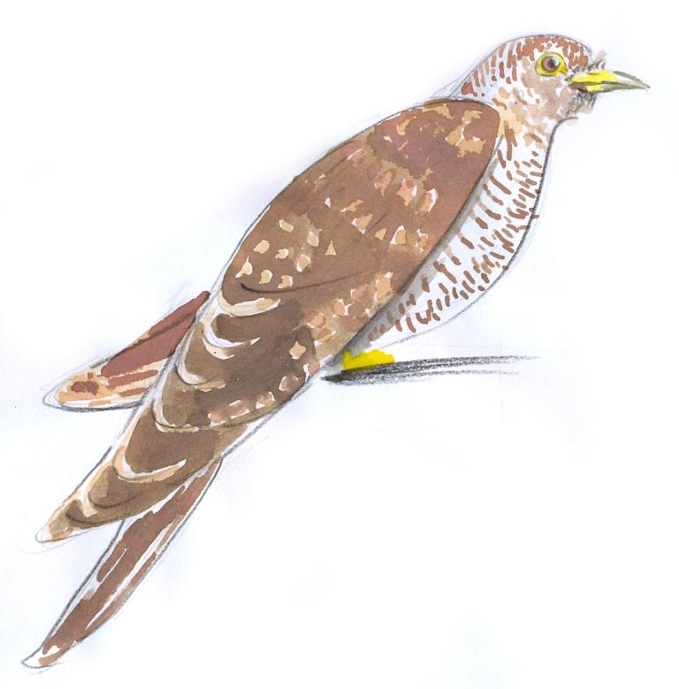 | When did You hear the voices of cuckoo  (Cuculus canorus)? | 1.5.05  2.125 | forest
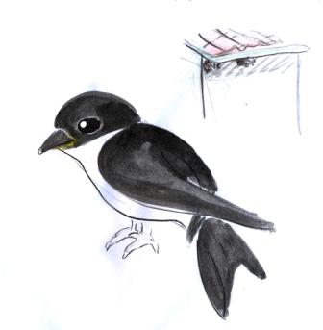 | When did You see the first house martin (Delichon urbica)? | 1.23.04  2.113 | village
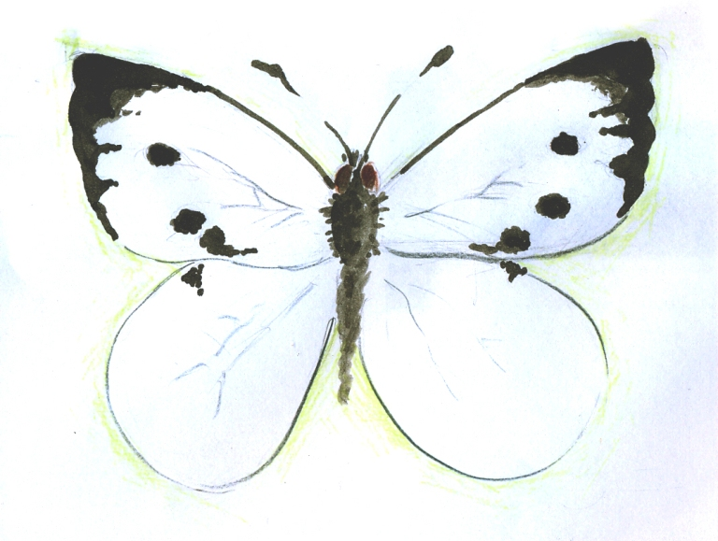 | When did You see the first cabbage white  (Pieris brassicae)? | 1.  2.
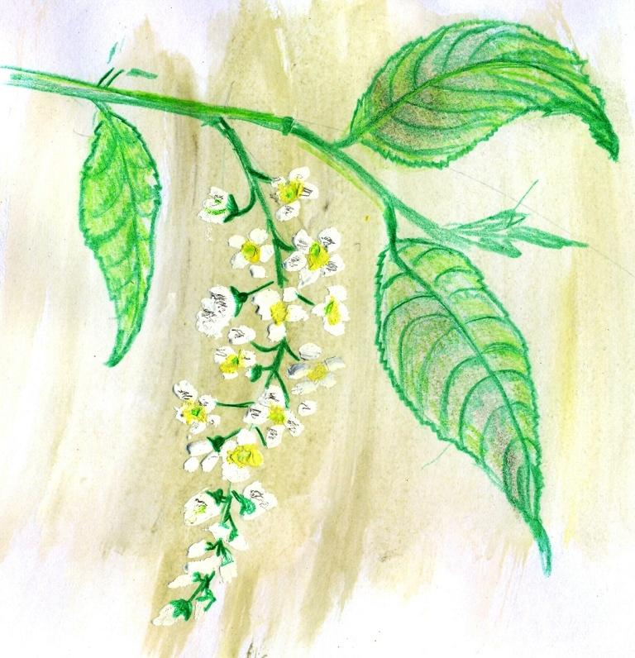  Baltic Sea Project Phenological Studies Programme | When did You see the first bird-cherry (Padus avium) being in bloom ? | 1.11.05  2.131 | park
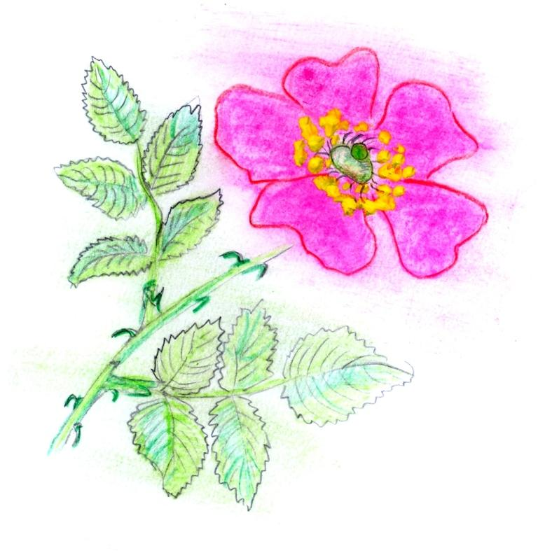 | When did You see the first dog-rose (Rosa canina) being in bloom? | 1.7.06  2.158 | town

© Pictures: Marta Dell’Oro, Vytautas Eidėjus

