Baltic Sea Project Phenological Studies Programme

OBSERVATION TABLE – SPRING 2015

Teacher name | Tiina Gashkov
Participant name and age  (or number of pupils) | 15 pupils, 13-14 years old
Name of school | Jõhvi Secondary School
Address of school/Code | Hariduse 5, Jõhvi 41 534
Country | Estonia
E-mail-address | Tiina.gashkov@mail.ee
Internet-address of school | www.johvig.edu.ee
Coordinates on the map | 59⁰35´, 27⁰42´

Picture of the species | What to observe | 1. Date  2. Day of 2015 | Place of observation (habitat), remarks
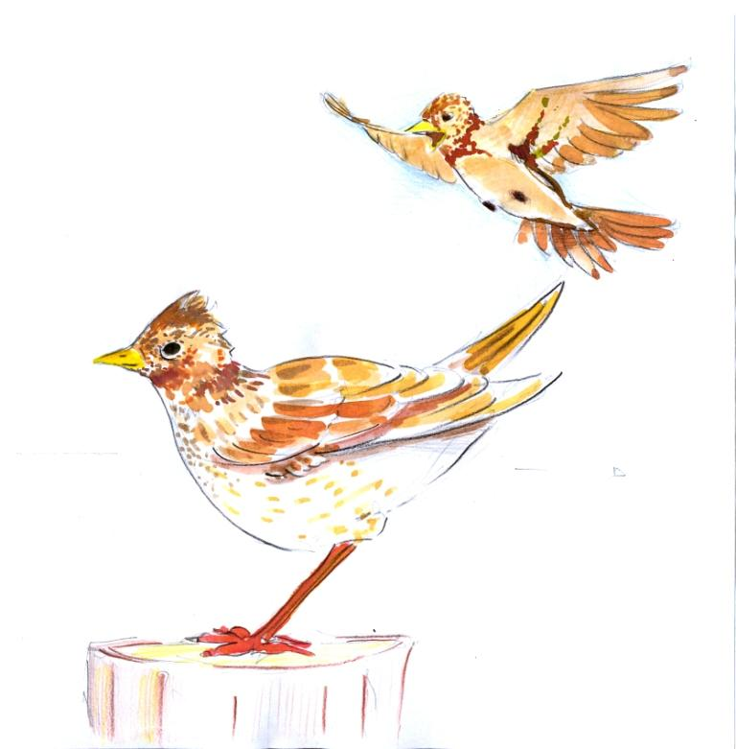 | When did You hear the voices of skylark  (Alauda arvensis)? | 1.10.03  2.69 | field
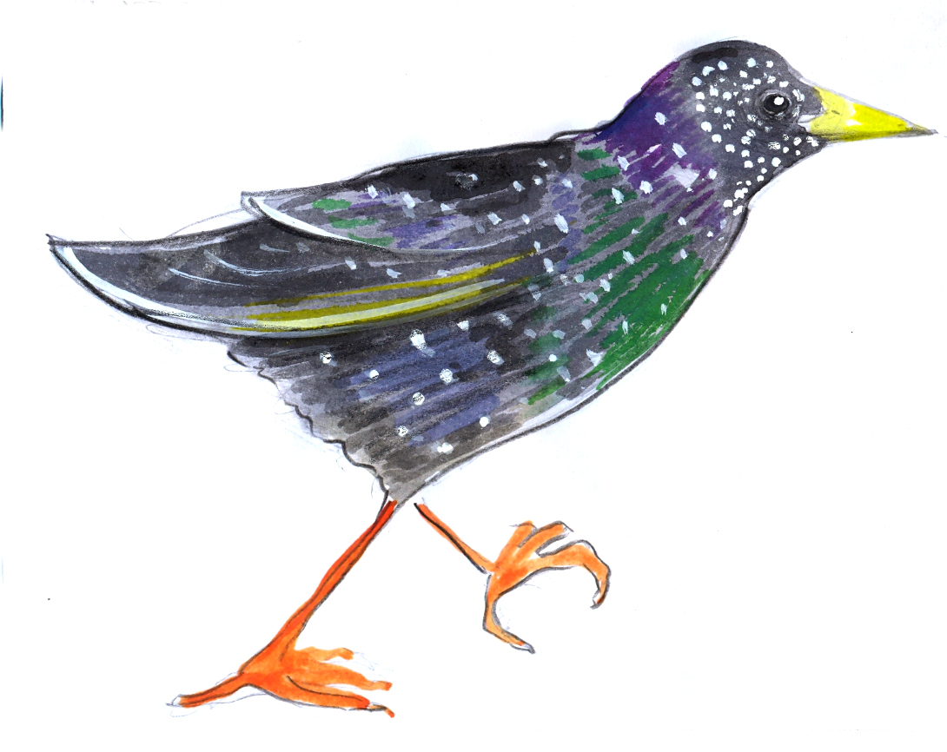 | When did You see the first starling (Sturnus vulgaris)? | 1.31.03  2.90 | town
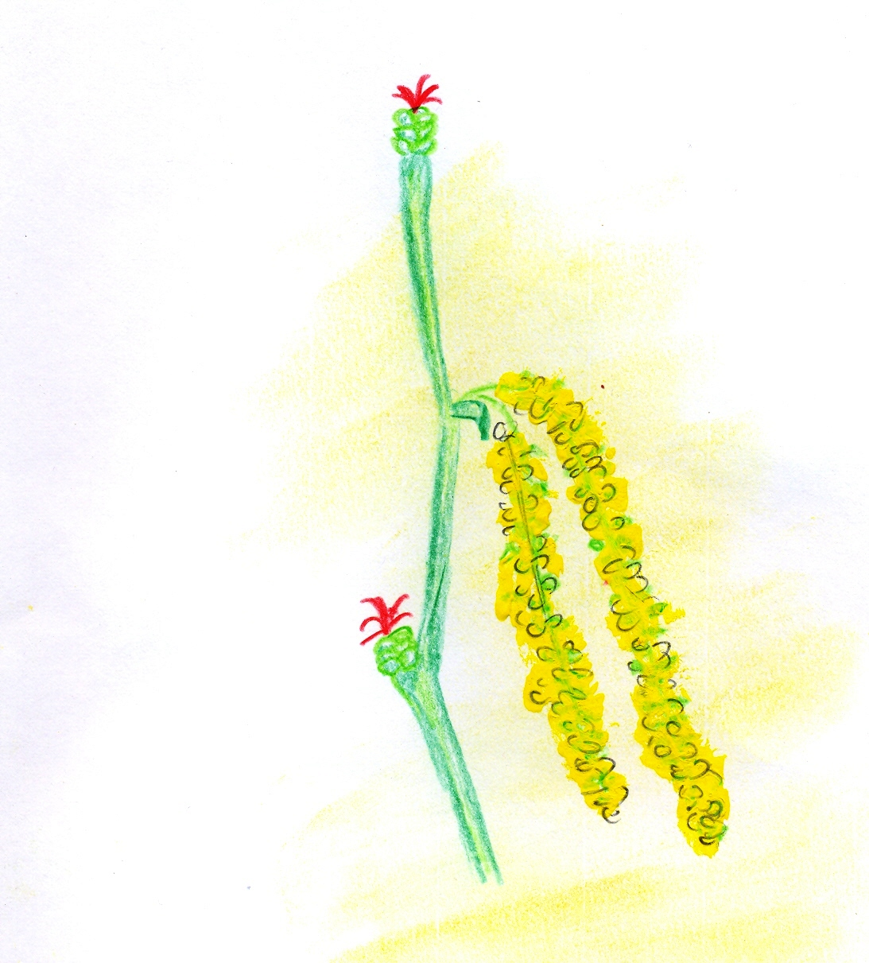 | When did You see the first hazelnut (Corylus avellana) being in bloom? | 1.7.03  2.66 | park
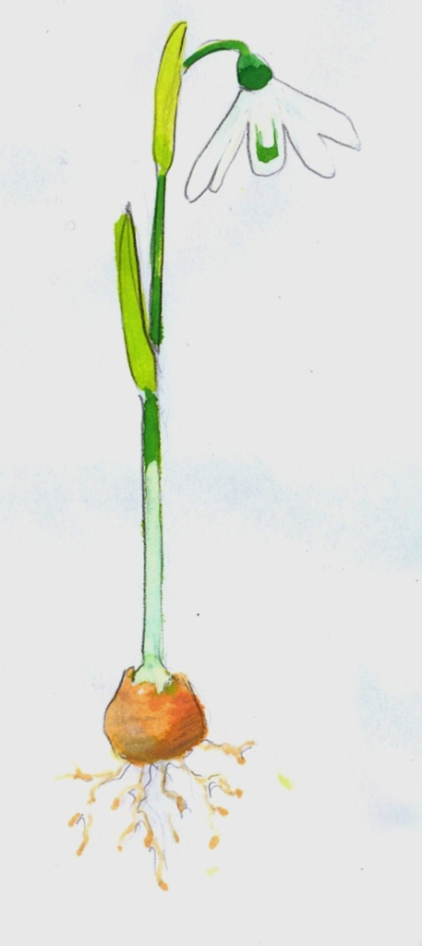  Baltic Sea Project Phenological Studies Programme | When did You see the first blooms of snowdrop (Galanthus nivalis)? | 1.4.03  2.63 | garden
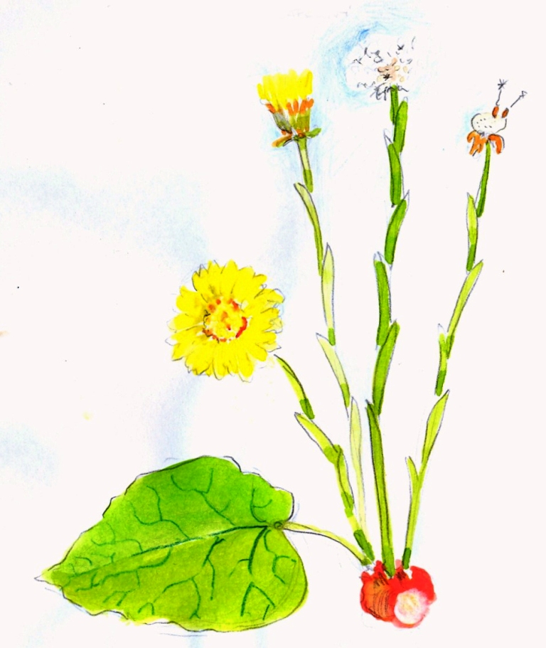 | When did You see the first blooms of coltsfoot (Tussilago farfara)? | 1.26.03  2.85 | field
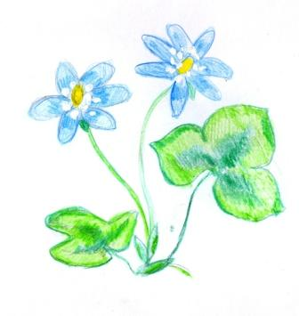 | When did You see the first blooms of blue anemone (Hepatica nobilis)? | 1.16.03  2.75 | park
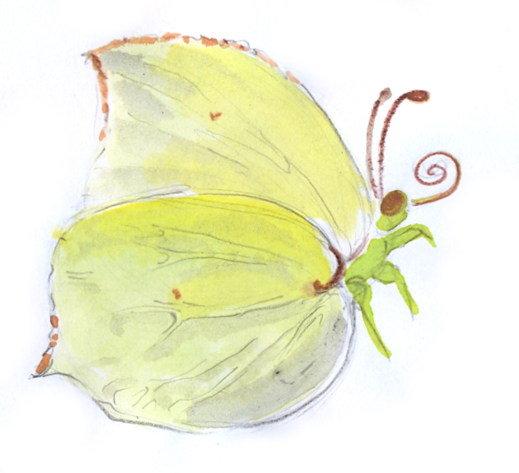 | When did You see the first brimstone (Gonepteryx rhamni)? | 1.15.03  2.74 | park
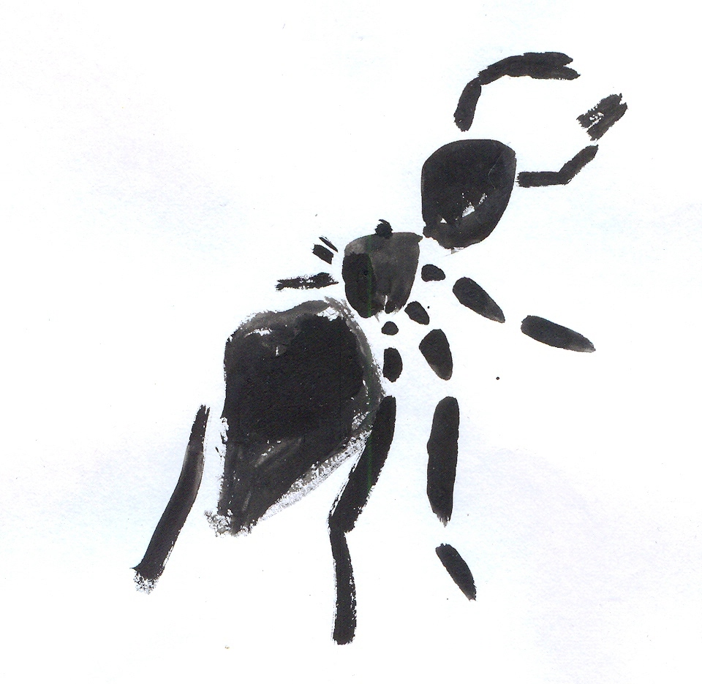 | When did You see the first black ant? | 1.15.03  2.74 | park
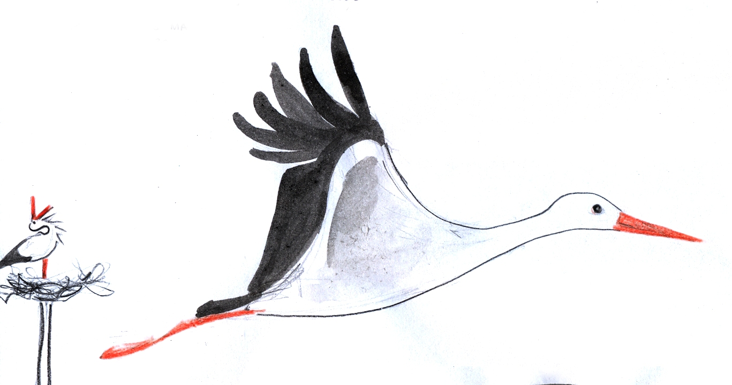 | When did white stork  (Ciconia ciconia) arrive? | 1.28.03  2.87 | village
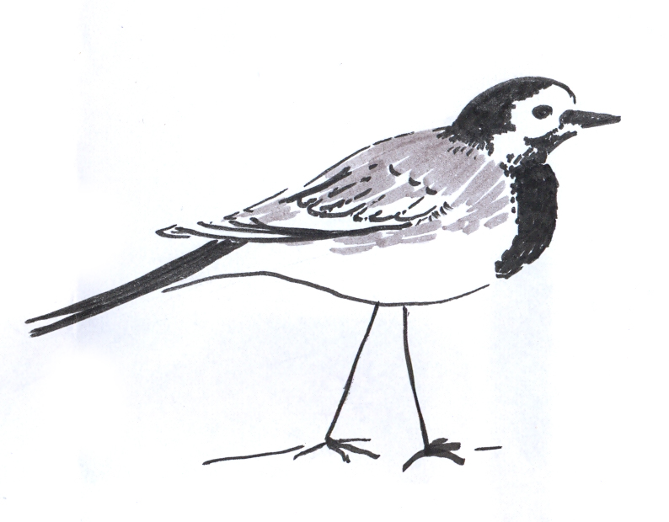 | When did You see the first wagtail (Motacilla alba)? | 1.12.04  2.102 | village
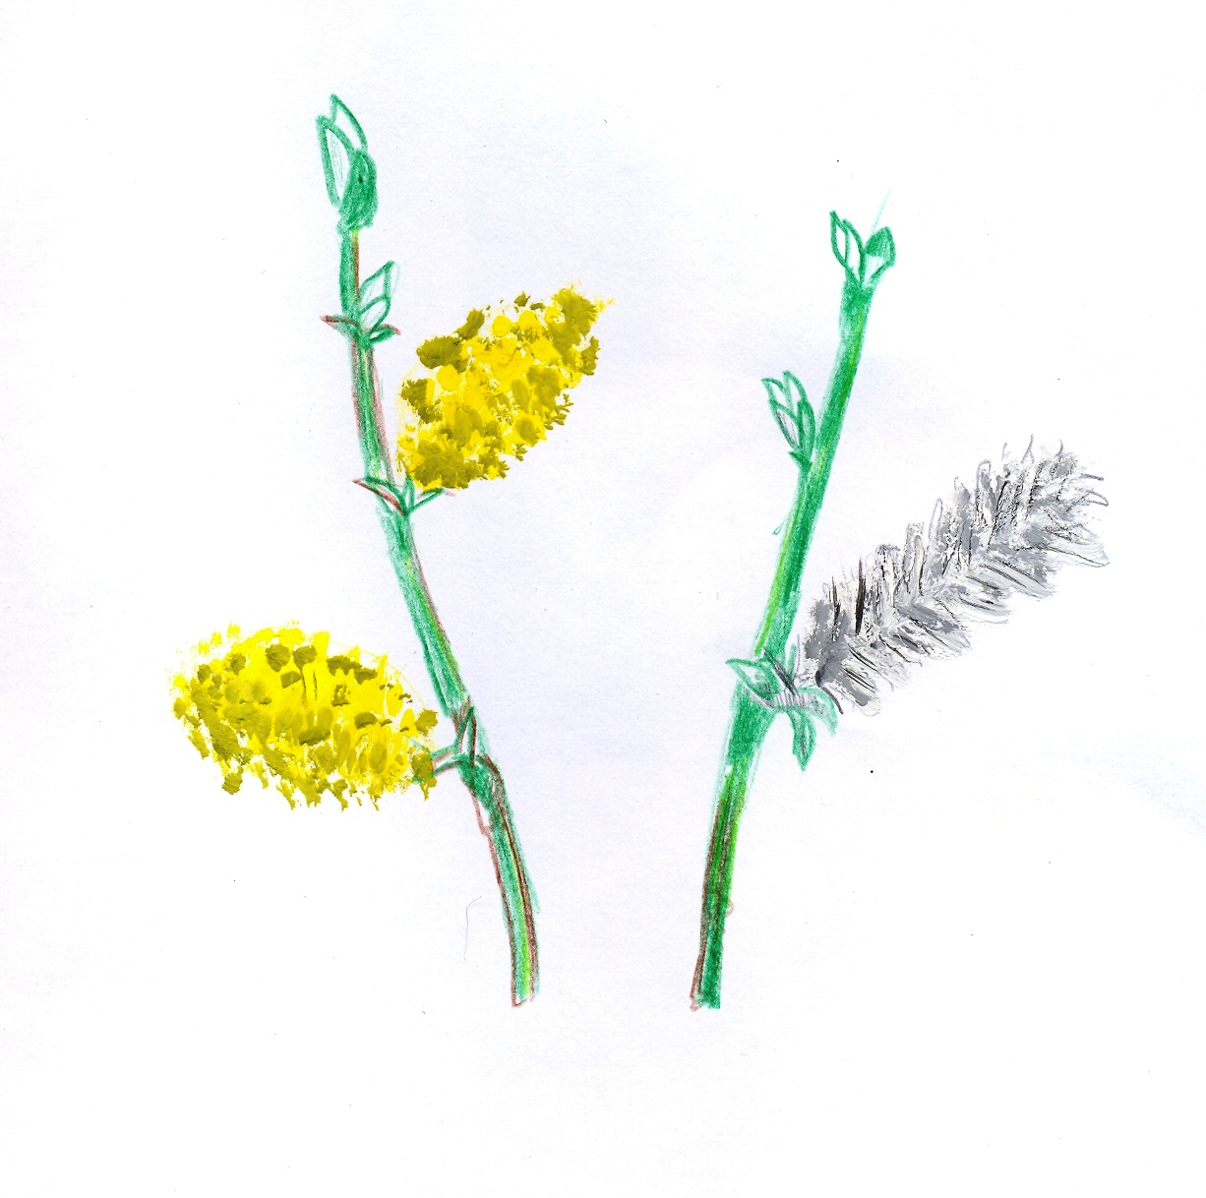 | When did You see the first sallow (Salix caprea)  being in bloom? | 1.20.04  2.140 | park
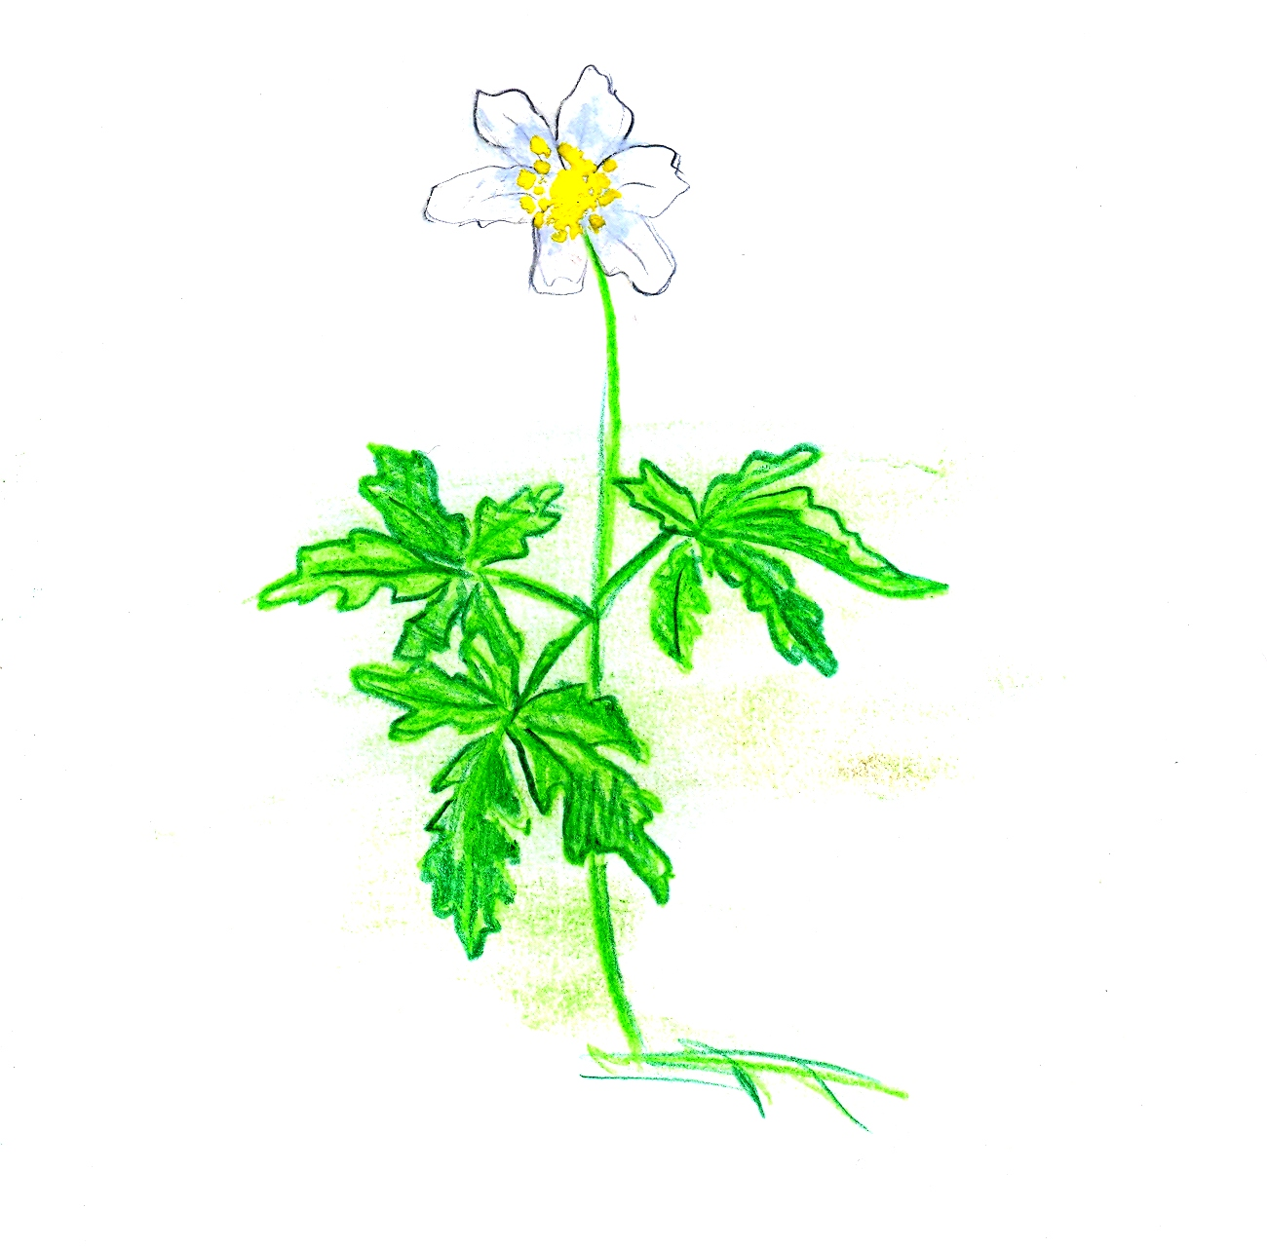 | When did You see the first blooms of wood anemone (Anemone nemerosa)? | 1.12.04  2.102 | forest
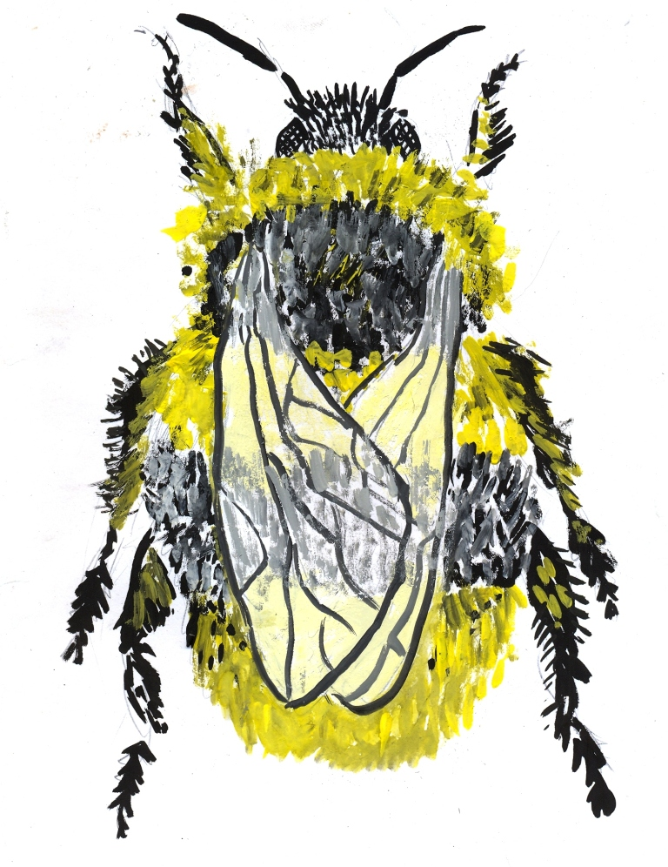 | When did You see the first bumble-bee flying? | 1.26.04  2.116 | field
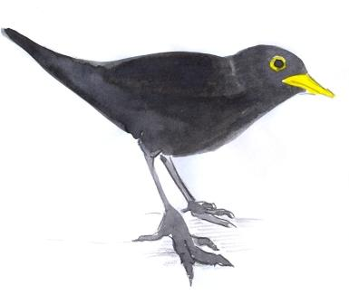  Baltic Sea Project Phenological Studies Programme | When did You hear the voices of blackbird  (Turdus merula)? | 1.5.04  2.95 | park
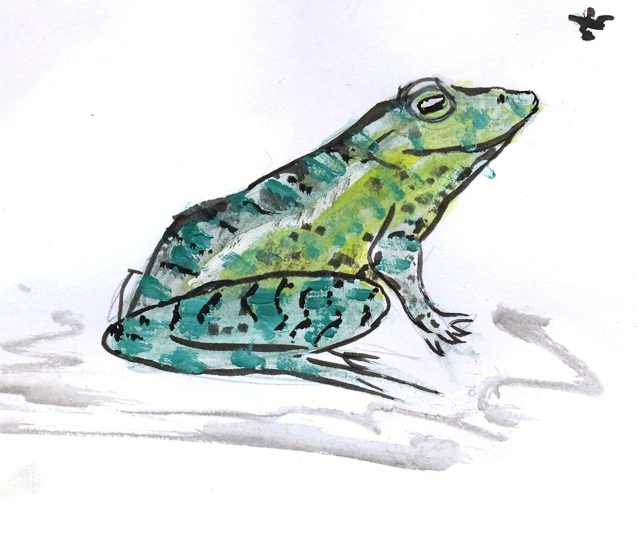 | When did you hear the “frog concert” in the vociferously breeding pond? | 1.11.04  2.101
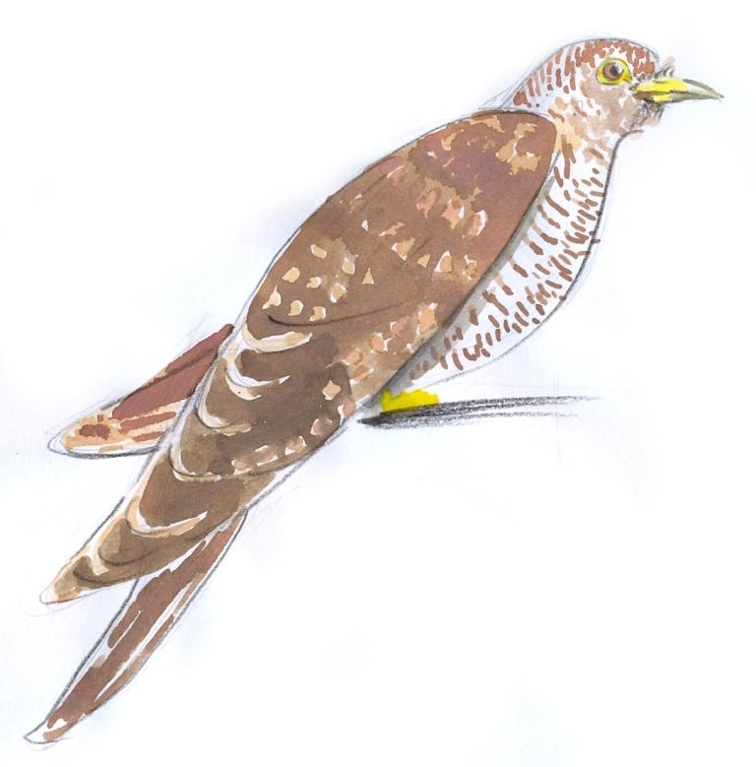 | When did You hear the voices of cuckoo  (Cuculus canorus)? | 1.10.05  2.125 | forest
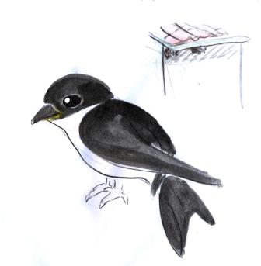 | When did You see the first house martin (Delichon urbica)? | 1.6.05  2.126 | village
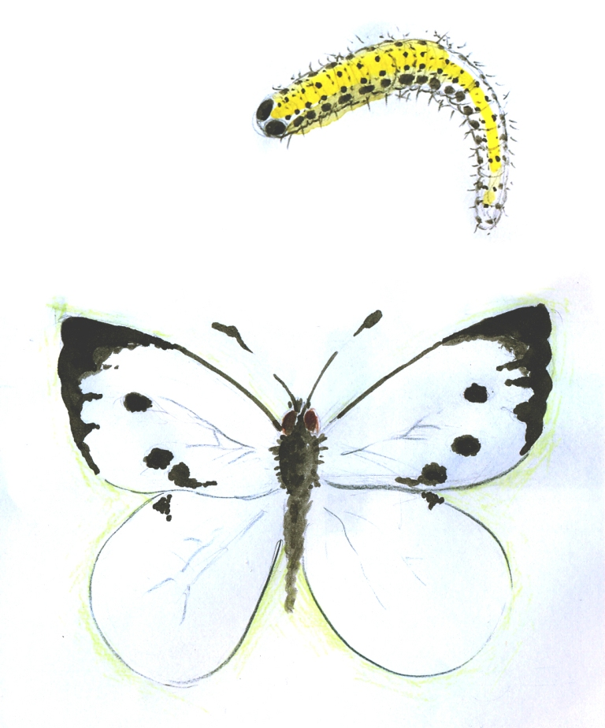 | When did You see the first cabbage white  (Pieris brassicae)? | 1.  2.
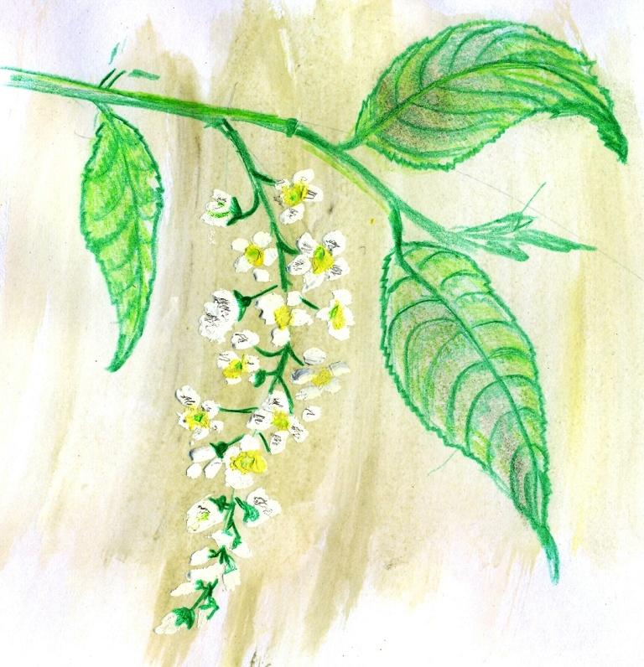  Baltic Sea Project Phenological Studies Programme | When did You see the first bird-cherry (Padus avium) being in bloom ? | 1.13.05  2.133 | park
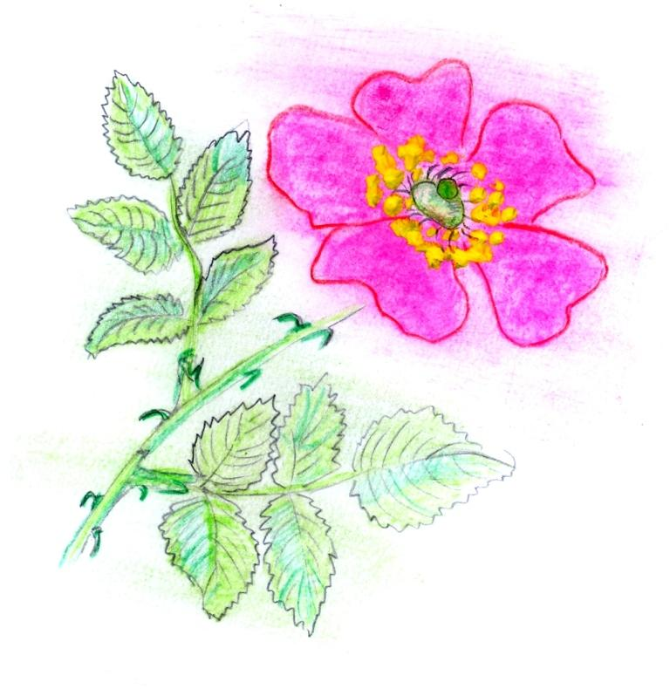 | When did You see the first dog-rose (Rosa canina) being in bloom? | 1.10.06  2.160

© Pictures: Marta Dell’Oro, Vytautas Eidėjus

